Install Kidsblock Software
Download link: www.kidsbits.net/Down/KidsBlock Desktop 1.1.3.dmg
- Download kidsblock，as shown below;
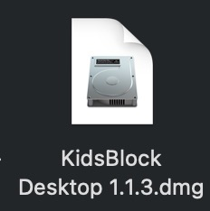
- Double-click KidsBlock icon，then drag 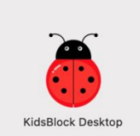 to the Applications folder.

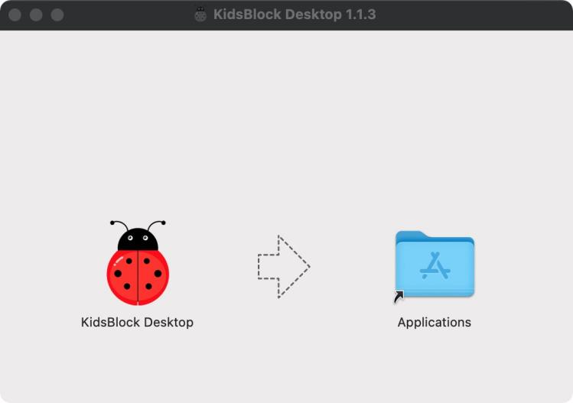

After the installation is finished, you will view KidsBlock icon.
